# Aim:

**Create UDF (User Defined Functions) in Apache Pig and execute it in MapReduce / HDFS mode**

To create UDF in Apache Pig and execute it in MapReduce/HDFS mode.

# Procedure:

**Pig Download and installation:**

1. Download Pig:

Download Pig from “https://downloads.apache.org/pig/pig-0.17.0/”

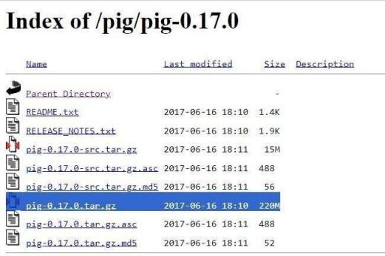

1. Add the environment variable for Pig:

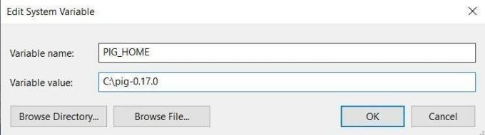

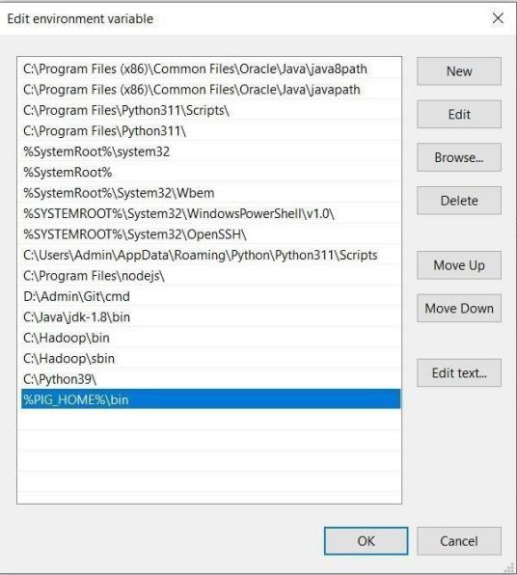

1. Go to C:\pig-0.16.0\bin and open pig (Windows Command Script)



1. Open Windows Powershell and type “pig –x local” and check whether pig grunt appears.

# Pig is successfully installed.

**Create UDF:**

# Start Hadoop services:

Open command prompt as an administrator

start-dfs.cmd yarn.cmd

start-

1. 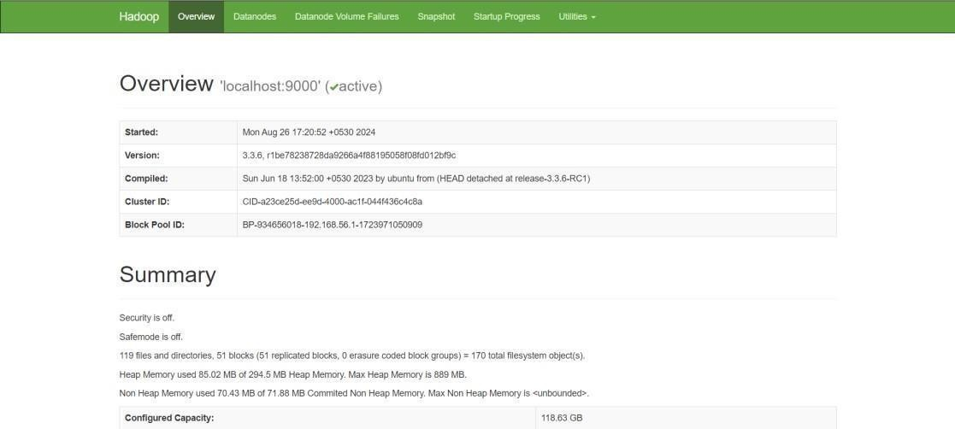Open the browser and go to the URL “localhost:9870”
2. Create a text file “input.txt”:

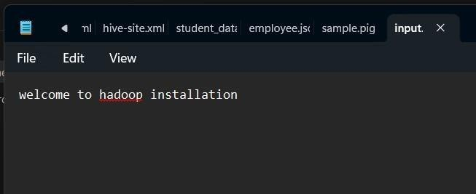

1. 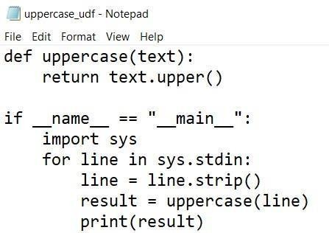Create a Python file “uppercase_udf.py”:

6.Create a Directory in HDFS and copy the Input File to HDFS

Hadoop fs -mkdir /piginput

hadoop fs -put udfs C:\pig\sample.pig /piginput

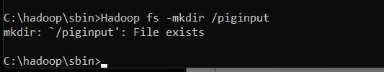

1. Create pig file “sample.pig”:

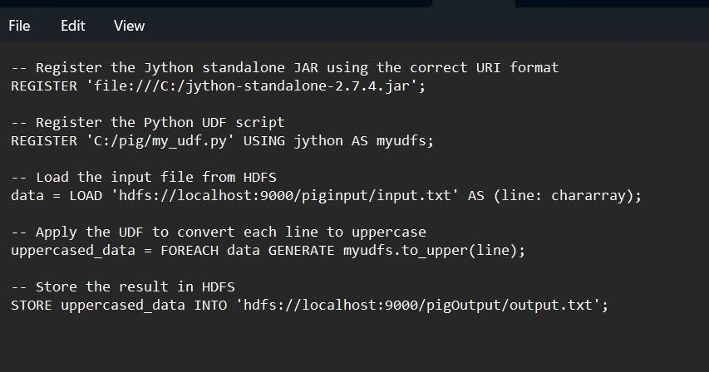

1. Execute Pig file:

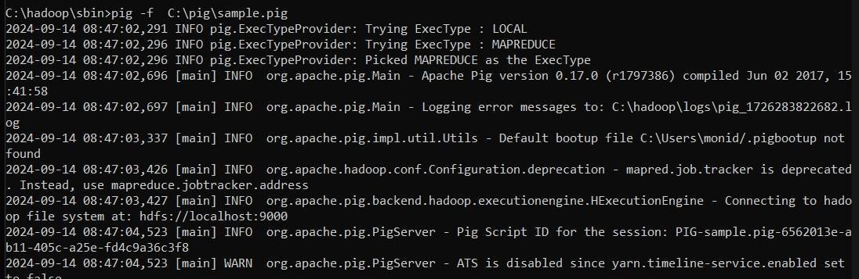pig -f C:\pig\sample.pig

1. View the Output hdfs dfs -ls /pigOutput

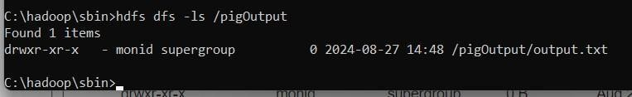

hdfs dfs -cat /pigOutput/output.txt/part-m-00000

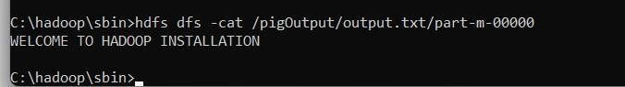

1. Once the map reduce operations are performed successfully, the output will be present in the specified directory.

“/pigOutput/output.data/part-m-00000”

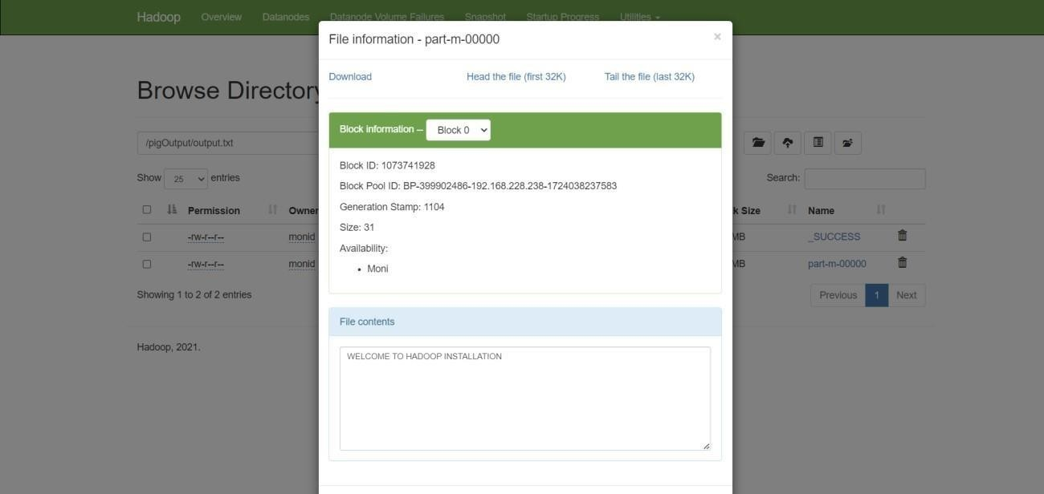

1. Stop Hadoop Services stop-dfs.cmd stopyarn.cmd

# Result:

Thus, UDF in Apache Pig has been created and executed in MapReduce/HDFS mode successfully.